**Claussen, Sophus (1865-1931)**

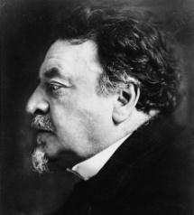

Sophus Claussen is considered one of the foremost Danish poets of the period spanning the nineteenth and twentieth centuries. As a regular contributor to the Symbolist journal *Taarnet* (1893-1894), published by Claussen’s fellow writer and friend Johannes Jørgensen (1866-1956), he became representative of a current which — apart from its Symbolist predicate — might aptly be described in terms of spiritual modernity. Sophus Claussen’s models were Charles Baudelaire, Paul Verlaine and Stéphane Mallarmé. In keeping with the so-called Modern Breakthrough spearheaded by Danish critic and scholar Georg Brandes, Claussen confronted the Church and traditional Christianity. It was a conflict that led Claussen not to enlightenment, realism and naturalism, but to a continued quest for a spiritual dimension, in direct opposition to the more profane modernism espoused by Brandes. Like the French Symbolists, Claussen perceived the manifestations of the world as representations of an underlying, all-encompassing divine truth with which the poet in his art was compelled to seek affinity. This neo-Romantic yearning towards a higher form of spiritual reality transcending visible (phenomenal) manifestations is accompanied in Claussen’s work by an apprehensive, sceptical consciousness whose only certain knowledge is that of its own ignorance.

Sophus Claussen was born on 12 September 1865 and died 11 April 1931. He grew up in rural Denmark in a family of farm owners. His father, Rasmus Claussen, was elected to the Danish parliament in 1872. He later purchased and founded several local newspapers, amassing some considerable wealth. The family’s financial standing was later to be of great benefit to Claussen’s work as a writer. In 1881 the family uprooted and moved to Copenhagen, where Claussen enrolled in the University’s law school and soon encountered the radical views that emanated from Georg Brandes and his Modern Breakthrough (female emancipation, antiestablishmentism, anticlericalism). Here, Claussen came into contact with other free-thinkers such as the poet Viggo Stuckenberg and the author Johannes Jørgensen, both of whom would later become involved in the Symbolist journal *Taarnet* (1893-1894). Claussen’s law studies were soon abandoned, and he became a newspaper editor. Claussen found economic support in his father and was thereby able to journey to Paris in 1892, where he entered the Symbolist circle surrounding Paul Verlaine.

The modernist schism between belief in the unique potential of art as a wellspring of truth, insight, and Romantic heaven, and despair at its obvious failure and the dissolution and destruction of all things, comes clearly to the fore in Claussen’s poem “Ekbátana” from the novel *Valfart* (1896). Claussen’s poetry often displays the idea of a universal force (eros) conquering death, the poet being seen as a chosen messenger of this all-pervading power. Such vitality, however, is often accompanied by a more demonic, destructive force, which — in accordance with Claussen’s Baudelaire-inspired modernity and monistic philosophy — is the other side of the same notion.

Alongside the early *Pilefløjter* (1899) and the late *Heroica* (1925), Claussen’s foremost poetic workis widely considered to be *Djævlerier* (1904).

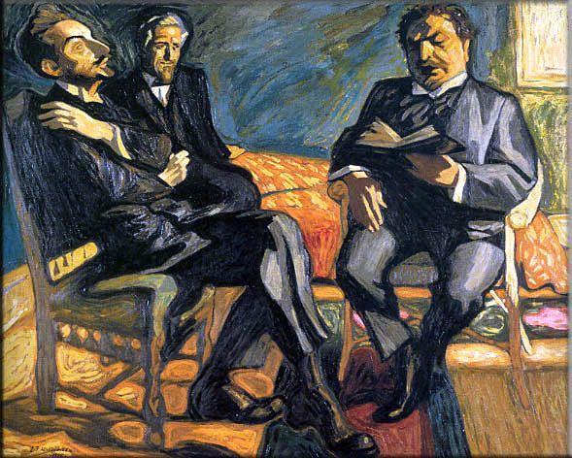

Danish symbolist and vitalist J. F. Willumsen’s portrait (1915) of Sophus Claussen reading his poem “Imperia” (*Danske vers*, 1912) to Willumsen himself (background) and author Helge Rode.

Listen to readings of Claussen poems on YouTube:

<http://www.youtube.com/watch?v=71s8nOXcTU8&feature=related>

<http://www.youtube.com/watch?v=I-9Zg1yPeoQ&feature=relmfu>

<http://www.youtube.com/watch?v=s50GOOsnhIg&feature=relmfu>

<http://www.youtube.com/watch?v=zrA7AR8SaB8&feature=relmfu>

**Chronology of Selected Works**

Novels, Short Stories, and other Prose

*Unge Bander* (1894)

*Antonius i Paris* (1896)

*Valfart* (1896)

*Fortællingen om Rosen* (1927)

Poems

*Pilefløjter* (1899)

*Djævlerier* (1904)

*Heroica* (1925)

**Further Reading**

Ringgaard, D. (2000) *Den poetiske lækage*. *Sophus Claussens lyrik, rejsebøger og essayistik*, Copenhagen: Museum Tusculanums Forlag Sørensen, Peer E. (1997) *Udløb i uendeligheden*. *Læsninger i Sophus Claussens lyrik*, Copenhagen: Gyldendal

Zeruneith, K. (1992) *Fra klodens værksted. En biografi om Sophus Claussen*, Copenhagen: Gyldendal